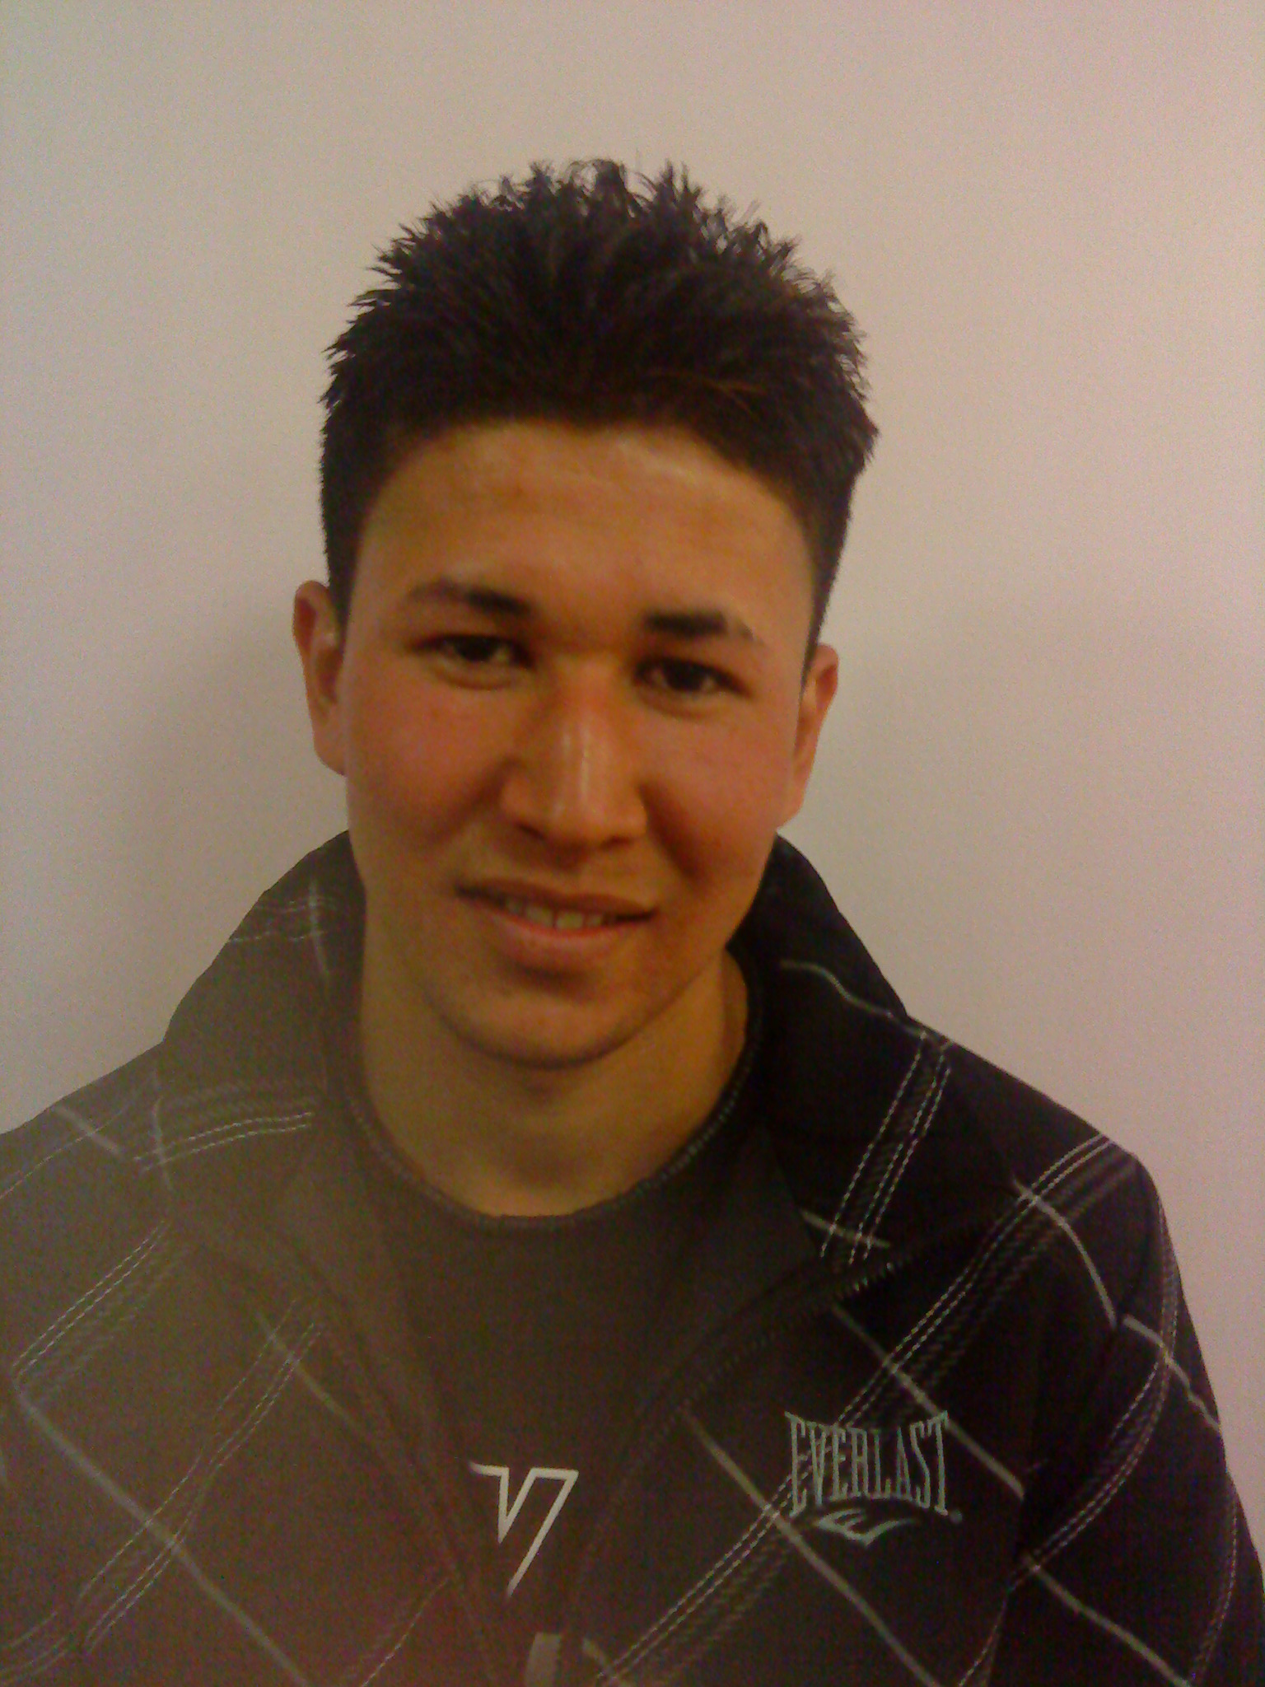
Save Reza- Afghanistan is not his home, he belongs to Sheffield
Reza Yosefi- Home Office Ref: Y1094016
Reza is a refugee with no nationality and long time resident of Sheffield:
I am 20 years old. I will be forcibly deported to Afghanistan on the 16th March 2011 even though I have no knowledge of Afghanistan and no family or friends there.
I grew up in Iran as the son of illegal Afghani refugees. I wanted to go school at 14, but was not allowed to attend. I wanted to work, but when I tried, I was arrested and badly beaten by the police.
At the age of 15, on fear of deportation I was sent to England to try to find a safe place where I could grow up. At 18 I was refused indefinite leave to remain and now, at 20, I am homeless, have no benefits and I am not allowed to work.
My situation is desperate. Now I am being deported. Please help me to stay in England. I want to study and work and live a normal life. I have friends in Sheffield and have made a life of my own here, please help me to continue living here in safety.
We the undersigned urge the Home Secretary to grant Reza Yosefi permanent permission to stay in the UK.
Name | Address | Signature
Please return the completed petition to: Save Reza- Afghanistan is not his home, he belongs to Sheffield. c/o 61 Rydal Road, Sheffield, S8 0UR

