Keep Tekeste Safe in Sheffield HO Ref: G1117473/5

Tekeste Gebrewold, whose father was killed as a member of the Oromo Liberation Front (OLF) in Ethiopia, tried to stop government supporters coming into his church, and was arrested for his involvement in OLF in 2004. He was ill-treated in prison and managed to escape to the UK and claimed asylum in March 2005.

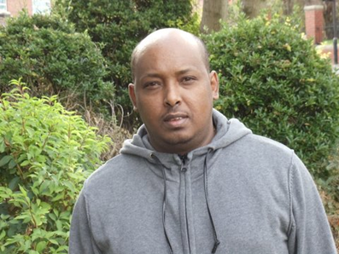
While here for the last eight years, Tekeste has attended OLF conferences and demonstrations, engaged in on-line OLF activities, and done voluntary work in the Sheffield Mobility shop and Conversation Club. He is an active and valued member of Holy Family Church, Gleadless, and Sheffield. The Ethiopian community of that church respect him for his quiet and sensible leadership. We believe that he should be given leave to remain in the UK safe amongst his many friends.

We fear for his life if he is returned to Ethiopia, where he would be in serious danger for his political OLF affiliation. The role he played as Arch Deacon in his church in Addis Ababa and his high profile make his situation all the more dangerous.

We, the undersigned, request that Tekeste Gebrewold be granted indefinite leave to remain here in the UK.

SIGNATURE | NAME (PRINT) | ADDRESS

PLEASE RETURN COMPLETED PETITIONS TO:
Holy Family Church, 20 Eastern Drive, Sheffield, S2 3WP

