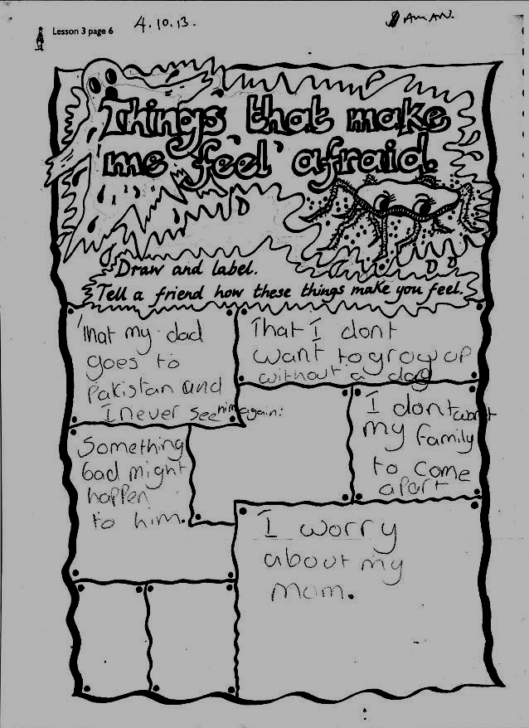
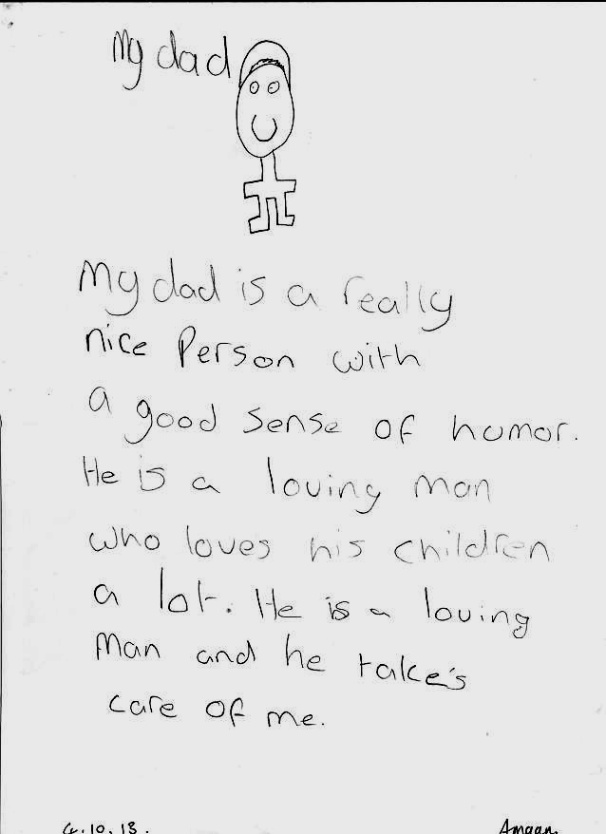


Shakeel Ahmed’s children need him to stay!

Dear Secretary of State- Teressa May (Reference A1033520.),

Shakeel Ahmed is facing deportation from the UK and forced separation from his family and 3 young children.. He has been in the UK for 14 years and has indefinite leave to remain. But the Government say he is a threat to the country
Shakeel has always worked , provided for his family and is a respected member of his community in Sheffield.
Despite being a mild mannered man and always maintaining his innocence, he was convicted in 2009 of conspiracy to supply Cannabis and was sentenced to a harsh sentence of 6 years for something which was completely out of character.
Now Shakeel has been made subject to a deportation order. The law says anyone who is not British and is sentenced to imprisonment for 12 months or over is automatically deported because it is presumed to be in the public interest, whether they are actually a danger or not.

Shakeel is a devoted father and his wife and children have an extremely close bond with him. His incarceration has already created extreme anxiety and depression for his family leaving his middle child with extreme emotional and behavioral difficulties. The children have been very happy and content upon Shakeel's return home on bail.
It is disproportionate that the home office intends to once again separate his children from their father. This is why he has a lot of support in the community opposing his deportation regardless of his custodial sentence.
He has been a model prisoner and licensee. The Probation Service assessed him to be the lowest risk possible. He poses no risk to society.

Under Article 8 of the European Convention on Human Rights, Shakeel's children, who are British, have the right to a family life with their father, without having to be uprooted from the country of their nationality, and the only place they have ever known.

We the undersigned ask the Secretary of State to respect the family life of Shakeel Ahmed, his wife and children and cancel the deportation order.

Name | Address | Signature

Please Return Petitions to Yasmin Ahmed 73 whiteways road Sheffield s4 8ew by the 24th December

